**ISE 222**

**Advanced Systems Engineering**



**Lithium-ion battery end-of-life life cycle assessment For Electric Vehicles**

**Prepared By:**

**Shreyash**

**Prepared for:**

**Prof. Dr. Behin Elahi  
Department of Industrial and Systems Engineering**

**San Jose State University**

**December 05, 2025**

**ABSTRACT**

The push for electric cars is boosting the need for lithium-ion batteries, raising worries about running low on materials, harming nature, or dealing with old batteries later. With tons of these power packs nearing the end of their use, we now have to get a clear picture of what happens during every phase they go through. Instead of just focusing on one part, this study pulls together findings from recent work that looks at how green these batteries really are - from making them to driving with them, fixing them up, reusing them elsewhere, and finally breaking them down again. Using data from long-term impact analyses, it checks how things like cleaner energy sources, drops in battery strength over time, how much stuff we can actually pull back out, and how long used units last in new roles - all shape emissions, strain on rare minerals, and whether the whole idea holds up well.

The research clearly shows cleaner power networks help cut down emissions from electric vehicles, whereas better recycling methods can pull out key metals and ease damage tied to mining. Fixing up old batteries or reusing them elsewhere adds value by making them last longer plus cutting need for fresh units - though gains differ a lot based on type, wear, and how studies define their limits. Even with progress in tech, hurdles remain like doubts over battery performance when reused, uneven recycling setups across areas, spotty return rates, and patchy alignment in worldwide rules.

Putting together results from several scientific papers, this work pinpoints top circular-economy methods for reusing EV batteries while showing when recycling or fixing them helps nature the most. Instead of guessing, it gives clear evidence on what works best at end-of-life - helping lawmakers, car makers, and power grid experts build smarter systems that save materials and last longer.

|  |
| --- |
|  |

**INTRODUCTION**

Electric cars are stepping into the spotlight as countries and businesses try to reduce emissions by ditching gas-powered rides. Thanks to lithium-ion tech, they’re able to go longer distances, sip energy instead of guzzling it, plus deliver stronger performance overall. Yet, that upside hides some deeper issues tied to their real-world footprint. As global demand climbs, so do concerns around just how clean battery life cycles actually are - mining raw stuff kicks things off, followed by power-hungry manufacturing, gradual degradation during use, finally disposal headaches piling up environmental harm along with cost troubles.

Life-cycle tests reveal electric car batteries harm nature in various ways. Extracting lithium, cobalt, or nickel damages ecosystems, pollutes air, while draining natural resources - this adds to climate change. Producing battery cells demands heavy electricity and high heat; when powered by fossil fuels, emissions spike sharply. Over time, worn-out units make vehicles guzzle more energy for regular trips, raising exhaust output later on. Each stage connects: you can’t assess impact only by performance - you must follow the build process, power sources used, plus recycling paths once discarded.

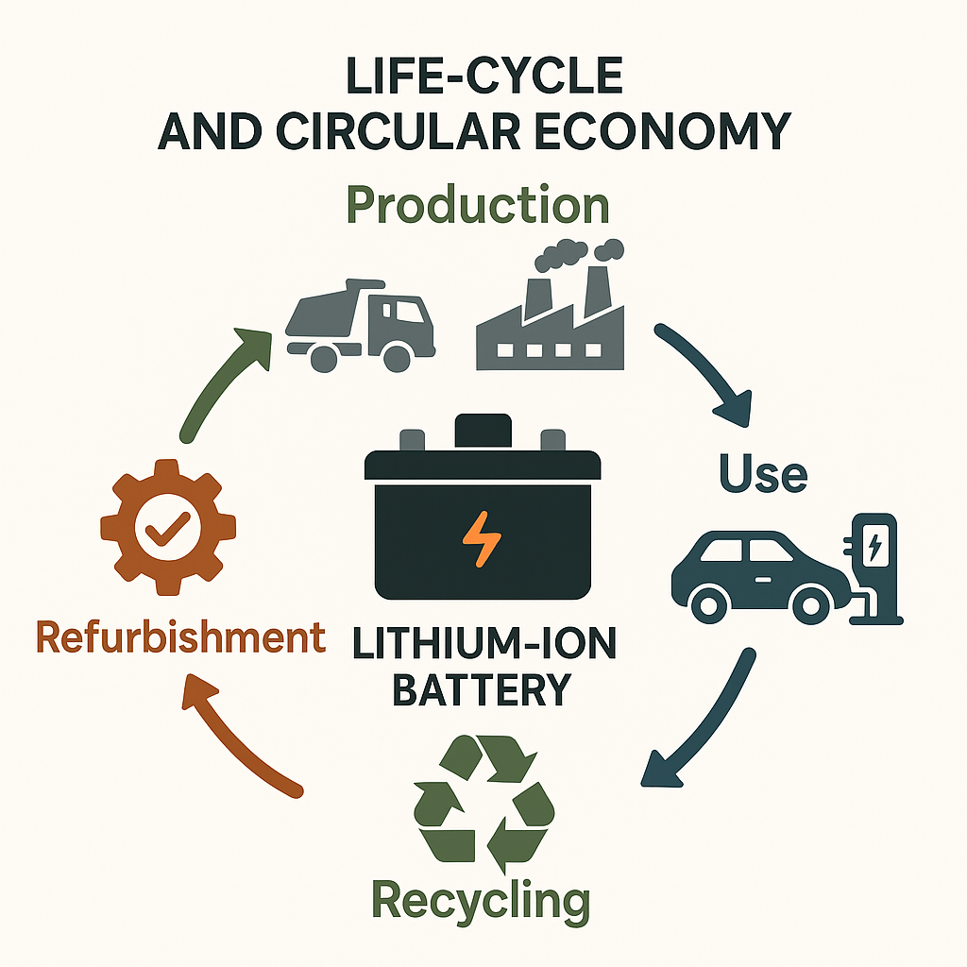

Millions of electric car batteries will soon stop working, so folks everywhere face a rising challenge - how to handle all those worn-out parts while avoiding fresh mining. Still, there's hope - it creates chances. Rather than trashing them, methods like repurposing, repairing, or disassembling extend how long we can use these materials. This cycle-based approach lowers emissions and reduces pressure on ecosystems. A new thought gaining traction? Giving old batteries a fresh role once cars no longer need them. When vehicles stop using these units, many lithium-ion packs still hold 70 to 80 percent of their original charge - making them solid choices for stationary storage systems. Rather than throwing them away, spent ones can back up solar or wind power, assist the electrical network during peak times, or jump into action when outages hit. Studies such as those by Pauli's group found reusing electric car cells reduces waste piling up. Besides that, it lowers emissions tied to producing completely new units from raw materials.

Recycling reduces pollution from lithium-ion batteries. Rather than creating fresh materials, processes such as chemical leaching, intense heat methods, or modern direct approaches recover valuable elements - lithium, cobalt, nickel, and sometimes copper. Research led by Dunn showed effective recycling cuts environmental damage while meeting part of regional demand, reducing reliance on imported raw goods. Advanced lifecycle assessments reveal that extracting metals from used batteries weakens climate change impacts, decreases dangers to human health, and supports more secure supply chains ahead. Yet performance varies widely based on location - it hinges on public battery return rates, available technology, current infrastructure, along with policy regulations.

The life of an EV battery links to how electricity sources evolve. Moving from coal to sun or wind means fewer emissions while charging, according to Koroma’s group. This highlights a core point - battery effects rely not only on cell design but also on broader energy changes. As power grids get cleaner, producing batteries harms the environment less, everyday driving becomes more eco-friendly, so long-term damage drops bit by bit.

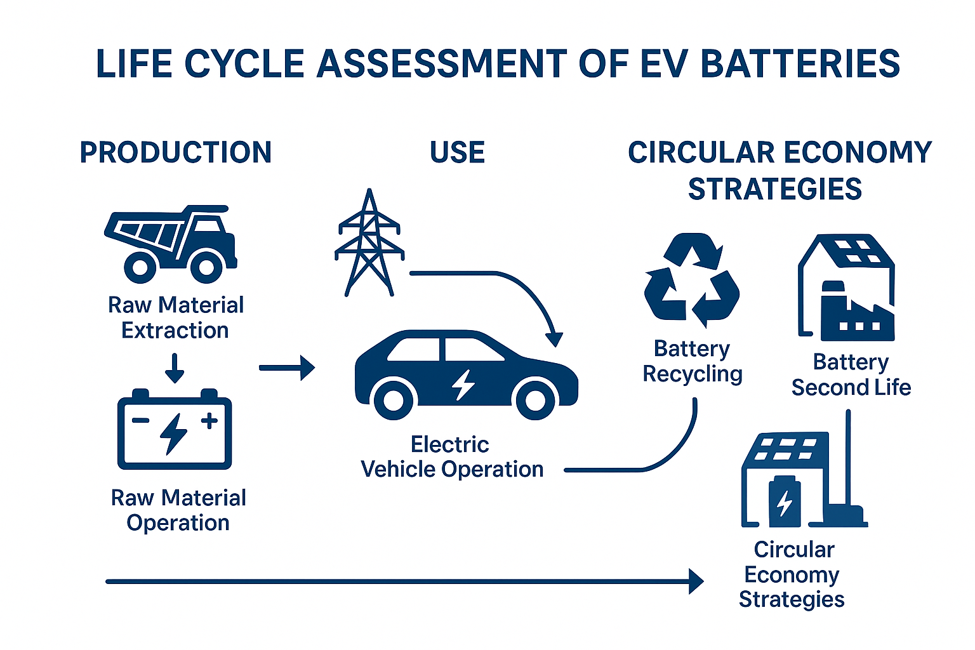

Even so, despite improved ways to monitor ecological effects along with cleverer reuse strategies, issues stick around. Without solid data from actual use on old batteries, it’s hard to judge their lifespan or durability accurately. Methods for recycling are improving - yet spreading them widely is tough, particularly in areas lacking infrastructure, where prices stay steep, plus availability differs place to place. Beyond that, since battery designs and components aren’t standardized, disassembling them eats up time and hampers recycling speed. Regulations together with incentives differ across nations, causing uneven outcomes when collecting discarded units or recovering valuable stuff.

When stuff gets messy, you need to step back - see how nature, money, and new tools fit together. We gathered clear findings from reliable places to trace what EV batteries do to Earth over their entire life. This covers pollution from building them, how they break down, chances to give them a second use, where recycling falls short, or how shifting energy systems change the game. With it all lined up, we find moments when loop-style fixes really work - and spell out practical steps to improve battery build, rules for managing them, and policies on lithium-ion units.

The outcomes shown aim to guide decision-makers, builders, inventors, or policy writers in building a stronger, tighter setup for electric car batteries. As worldwide changes push electrified systems ahead, dealing with old lithium units wisely becomes increasingly key - reducing harm from waste while supporting reliable material flows toward greener energy paths.

**LITERATURE REVIEW**

**RESEARCH PAPER – 1 [Lithium battery reusing and recycling: A circular economy insight]**

----------------------------------------------------------------------------------------------------------------------------------

|  |  |
| --- | --- |
| **Author** | **Mario Pagliaro**  **Francesco Meneguzzo** |
| **Objective** | **The research paper aims to:**   * Provide an **updated global perspective** on the reuse and recycling of lithium-ion batteries (LIBs). * Analyse recycling methods while checking if pulling out useful metals like Li, Co, Ni, or Mn makes financial sense. * Check out circular economy ideas - focusing on reused batteries. Look into how old batteries can serve new roles instead. |
| **Methodology** | **This paper looks at existing reviews to analyze data. The approach uses methods like:**  **a) Technology & Chemistry Assessment**   * Dig into how LIBs work, what they’re made of, how they wear out, while also looking at recycling options once they’re done. * Looking at how materials are recovered using mechanical methods, water-based chemical techniques, or high-temperature treatments. * Looking at fresh eco-friendly chemical methods - like these ones * Citric acid + H₂O₂ leaching (98–99% metal recovery) * Sodium persulfate oxidation for LFP batteries (99.9% Li recovery) * Looking at how factories reuse materials - pics on page 3 display how well metals dissolve, also the breakdown stages.   **b) Circular Economy Evaluation**   * Looking into old car batteries used for fixed energy storage (Page 2: Example from Amsterdam Arena setup). * A look at worldwide reuse efforts - like China’s telecom tower project.   **c) Economic & Market Analysis**   * Review of: * Price trends of Li & Co * Market growth * Manufacturing constraints * International recycling practices * Looking into rules and policies - especially how China handles tracking stuff plus reusing materials. Checking what laws exist for recycling, along with systems that follow products through their life cycle. |
| **Findings** | **Important** **points taken from the article:**  **Battery Reuse**   * EV batteries keeping 80–85% charge often find new life holding power for the electrical network. * Big second-use setups - like the 2.8 MWh one at Amsterdam Arena - show they’re ready for real business use.   **Recycling Technologies**   * Old-school metal extraction using water or heat works well, yet it’s expensive while harming nature quite a bit. * Green chemistry breakthroughs now offer: * High recovery rates - cobalt at 98%, lithium reaching 99% * Low toxicity * Closed-loop recovery * Lower chemical consumption   **Economic Advantages**   * More than 90 percent of a used battery's worth comes from materials like lithium, cobalt, nickel - also copper, aluminium, manganese. * Faster switch to electric cars pushes up need for top-quality battery stuff - so reusing old parts turns into big money.   **Global Recycling Trends**   * China leads LIB recycling with: * Massive industrial capacity * Strong regulatory framework * Government-funded research * Guess what? Around two-thirds of the world’s lithium-ion battery recycling might happen in China come 2025.   **Circular Economy Benefits**   * Battery reuse plus recycling cuts wastes a lot * Material extraction * Environmental harm * Waste generation * Fuels teamwork among makers and reprocessors - so taking things apart or using them again gets simpler. |
| **Results** | * Green ways to recycle pull out over 98% of metals using gentle, cheap setups. * LFP-focused recovery method creates nearly pure lithium carbonate - ready to use in fresh battery production. * Second-life uses help lower high electricity spikes, skip the need for diesel backups, also keep power networks steady. * Recycling markets are expanding at high speed, driven by: * EV adoption * Material shortages * Policy requirements * Factories are growing worldwide - places like Korea, then Europe, also the U.S., plus China. |
| **Limitations** | * The study points out - or at least suggests - some boundaries: * Early recycling methods aren't totally green - so they need upgrades. * How well second-life batteries work - or how long they last - can be hard to predict, depending on where they’re used. * Want better robots plus uniform cell shapes - so taking things apart gets easier. * Green chemistry methods show potential but haven't been fully tested in real-world factories yet. * Relying too much on China's recycling system could lead to shaky supplies now and then. * Lots of nations using different rules makes it tough to spread high-tech recycling worldwide. |

**RESEARCH PAPER – 2 [Lithium Battery Reusing and Recycling: A Circular Economy Perspective]**

|  |  |
| --- | --- |
| **Author** |  |
| **Objective** | * Check out ways old lithium-ion batteries might get another use - or turned into new stuff inside a looped-up resource cycle. * Check eco-friendly perks plus material gains from using old EV batteries again prior to breaking them down. |
| **Methodology** | * A close look at ways to reuse stuff, while also checking how well recycling methods work. * Look at how circular economy ideas work alongside battery life cycles. Yet focus stays on recycling methods tied to energy storage use. * Looking at green results through eco-friendly measures - while checking progress via real-world impact instead of vague promises. |
| **Findings** | * Using things again for new purposes slows down trash buildup. * Today’s recycling systems can't handle blended chemical flows - so problems pop up here and there. * Circularity chances rely heavily on what the battery’s made of as well as its layout. |
| **Results** | * Using old batteries again before tossing them helps save resources while cutting down harm to nature. * Reusing old stuff matters - especially to get back things like cobalt, or nickel, maybe even lithium. |
| **Limitations** | * Not knowing how long used batteries will last. * Not much info on how recycled batteries work in daily use. * How recycling works differs a lot in how well it runs plus what kind of impact it leaves on nature. |

**RESEARCH PAPER – 3**

|  |  |
| --- | --- |
| **Author** | **Jessica Dunn - then Alissa Kendall alongside her - Margaret Slattery followed close behind.** |
| **Objective** | * Figure out practical recycling targets for cobalt, lithium, or nickel used in electric cars across the U.S. * Check how home recycling affects money and nature compared to sending it overseas - like China - for processing. Look at local benefits alongside global trade effects instead of just one side |
| **Methodology** | * Material Flow Analysis (MFA) from 2020–2050 to estimate supply and demand. * Life Cycle Assessment done with Argonne's EverBatt along with GREET tools. * Picture 864 different setups - each one mixes up electric car sales, battery types, reuse options, how they’re recycled, also pickup levels. |
| **Findings** | **Domestic recycling can meet part of future US demand:**   * 2030: 11–12% cobalt, 7–8% lithium, 10–12% nickel. * By 2035: around 15 to 18 percent cobalt, roughly 9 up to 11 percent lithium - also about 15–17 percent nickel. * Pyro works differently from hydro when it comes to output and price. Direct recovery isn't the same either in how much it saves or spends. * Recycling costs less in China because the setup's already there |
| **Results** | * Recycling cuts down CO₂, SOx - also NOx pollution compared to trashing stuff. * Local recycling can work financially when done big-time - yet it’s pricier compared to shipping waste abroad. * Rules need backing so recycling stays high plus RCS gets used. |
| **Limitations** | * Few people agree on what kinds of batteries will power future cars or how many will sell. * Limited info from actual use on how well second-hand units last or break down. * Future upgrades in recycling tech aren't shown directly. |

**RESEARCH PAPER – 4**

|  |  |
| --- | --- |
| **Author** | **Koroma - then Costa, followed by Philippot; next up, Cardellini alongside Hosen; after them, Coosemans together with Messagie.** |
| **Objective** | * Look at how the coming power sources, battery wear, repairs, or reuse together shape electric car impacts. * Check how reused batteries affect total emission levels over time. |
| **Methodology** | * Material Flow Analysis (MFA) from 2020–2050 to estimate supply and demand. * Life Cycle Assessment done with Argonne's EverBatt along with GREET tools. * Picture 864 different setups - each one mixes up electric car sales, battery types, reuse options, how they’re recycled, also pickup levels. |
| **Findings** | * Test-driven LCA following ISO 14040/44 rules. * Three scenarios: * Baseline setup using today’s power sources - no upgrades included * Flexible (what power we’ll use later) * Refurbished battery scenario * System limits cover getting materials, then making products, followed by how people use them, what happens after they're done being used, also fixing them up again. * Driving a battery electric vehicle for 12 years, covering 160,000 kilometers. |
| **Results** | * A greener power supply cuts BEV emission by nearly 9.4%, since the grid's fuel sources play a big role in overall impact. * Recycling cuts pollution by just over eight percent. * Battery fixes bring tiny climate gains - unless they last way longer. * Battery wear pushes up electric car pollution during use by around 7.4 to 8.1 percent. |
| **Limitations** | * Used estimates for second-life performance - no real data available. * Leaves out effects from stored power systems so we can stick to battery cars. * LIB production is expected to take place in Korea - other areas aren't included in this setup. |

**PROBLEM STATEMENT**

The fast growth of electric cars means we now have to look closely at how lithium-ion batteries affect the environment from start to finish - they’re still one of the heaviest burdens in making EVs. Even though these vehicles cut exhaust pollution, building their batteries takes a massive amount of energy while mining key materials like lithium, cobalt, and nickel; those steps harm nature, worsen global warming, and drain limited supplies over time. With more old car batteries piling up as they wear out, today’s ways of gathering them back, giving them second uses, or breaking them down aren’t ready enough - or built the same across regions - to handle what's coming.

Studies say none of the options - like reusing, recycling, or repurposing old batteries - fully solves every environmental problem on its own. Some recycling methods work better than others, pickup systems differ around the world, while used batteries bring worries about how safe they are, whether they’ll last, and if they can be trusted. On top of that, how green an electric car battery really depends heavily on things like local power sources, how it’s built, how fast it wears out, plus shifts in demand and pricing - all of which makes picking the best way forward a tough call without looking at the full picture.

Because of these issues, we must check how eco-friendly electric car batteries really are by looking at their full life cycle - from making them to running them, reusing them later, or getting materials back. This work tackles a gap: there’s no solid proof showing which way works best once batteries wear out - whether it’s recycling, fixing up old ones, or giving them new jobs - when it comes to helping the planet, saving resources, and building a closed-loop system for batteries. If we don’t figure this out, governments, companies, and recyclers won’t know how to set rules, design tech, or build systems that actually make battery use sustainable.

**METHODOLOGY**

This project uses a step-by-step approach to study how eco-friendly lithium-ion batteries are from start to finish. Built on ideas from Life Cycle Assessment, systems thinking, and comparing past research, it pulls key points from five trusted scientific papers looking at making batteries, how they work during use, reuse options, and what happens at the end - like recycling or fixing them up. Together, these pieces give a clear picture of which ways to handle batteries hurt or help the environment.

1. **Research Design and Approach**

The study uses a qualitative approach to compare different research works, pulling together results from several academic articles that rely on life cycle assessments. While focusing on electric vehicle battery sustainability, these studies were picked due to how relevant they are, how solid their methods are, also because they look into circular economy strategies. Instead of collecting fresh data, the goal here is to gather existing evidence, which fits well with analyzing whole systems. This makes it useful for broader insights without needing original experiments.

Every essay got checked using six main areas:

* Authors
* Objectives
* Methodology
* Findings
* Results
* Limitations

This clear method keeps results steady from one study to another - making comparisons actually useful.

**2. Life Cycle Assessment (LCA) Framework**

Carefully using LCA ideas shows how one step affects total impact. Instead of skipping pieces, it looks at all key stages through a lithium-ion battery’s whole lifespan

Raw Material Extraction (lithium, cobalt, nickel, manganese, copper)

Battery making involves creating cells, then putting them together into modules while using electricity throughout the process

How it’s charged, how it ages, what kind of power supply is hooked up

End-of-Life Scenarios:

Recycling means trading outdated habits for clever water shortcuts, smart heating ideas, or simply reusing things instead

Fix old batteries by checking each cell, moving parts around, then using them again where they work well

Tossing garbage away – or leaving it behind when there’s no way around

The LCA methods in those studies go from start-to-finish, raw materials to factory output, or even circular setups. Right off, these differences show up - then get lined up side by side - to see if picking one way instead of another shifts what we think is truly green.

**3. Comparative Analysis of End-of-Life Pathways**

To check how well things work at end-of-life, this approach looks at three main routes - comparing each one differently

**a. Recycling**

Looking at how well it works, plus what’s recovered from materials, how clean the output is, or its effect on nature.

Research looked at various ways to recycle - like using chemical baths, melting methods, or simply pulling parts apart by hand.

**b. Refurbishment**

Looking at steps that check, group, or reuse old batteries - like using them later to store power.

Folks looked at how fast things wear out, what condition they're in, how well they turn energy from one form to another, also how long they might last after their first use.

**c. Second-Life Deployment**

Looking at how much harm to nature is avoided by using old EV batteries instead of brand-new ones - especially when adding solar or wind power, also helping keep electricity grids stable.

These tests used real-world data from past studies - like how much CO₂ was released, power used, rare materials needed, or trash produced - to show differences.

**4. Assessment of Electricity Mix and Use-Phase Scenarios**

Knowing power sources shift by place and hour, this approach uses live grid data pulled from several reports.

Scenarios include:

* Current fossil-dominated grids
* Switching power systems using some green energy
* Futuristic energy blends with less carbon or totally green sources

These examples show how usage effects change when power sources get cleaner - since energy shifts alter outcomes. Yet patterns adapt as tech improves; because demand transforms over time.

Battery wear models from past studies pop up here to show how dropping performance affects charge needs along with overall pollution.

**5. Synthesis and Interpretation**

Once the info’s pulled from all five studies, it uses a theme-based mix method

1. Finding similar trends in research - like how manufacturing often leads, why recycling helps, or what role power sources play
2. Finding common ground when system limits differ or methods assume different things
3. Linking ideas from the circular economy to build one clear view on how to keep lithium-ion batteries sustainable

This mix helps shape a clear takeaway along with next-step ideas.

**6. Limitations of the Methodology**

This study uses existing data instead of new models, so findings hinge on how solid and full the chosen sources are. Varying scopes, measurement methods, locations, or expected recycling rates can create gaps in accuracy. Such issues were flagged early and shaped how results were weighed and shared.

**Summary**

This method uses a clear review of past studies, life cycle basics, side-by-side option checks, but also big-picture analysis to see how making batteries, how people use them, plus what happens at end-of-life affects their eco-impact. Combining these pieces helps spot when reusing, fixing up, or recycling packs the biggest green advantage - yet it also shows roadblocks standing in the way of creating a closed-loop system for EV cells.

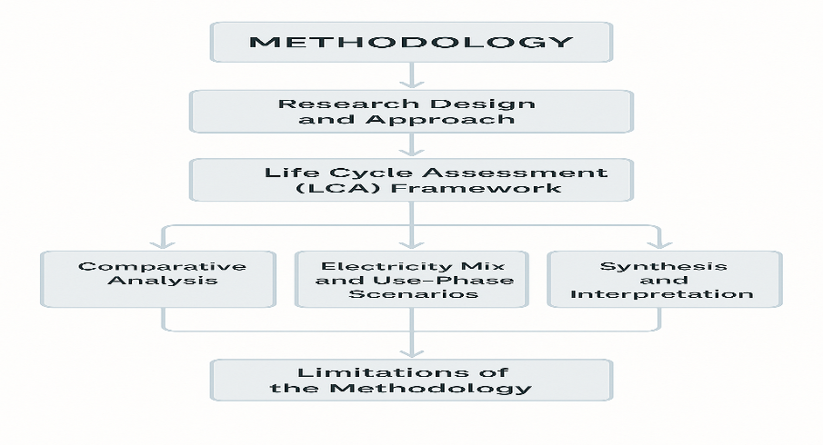

**CONCLUSION**

The rise of electric cars has put lithium-ion batteries front and centre in chats about a greener future. But even though they pollute less while running, making them damages nature - from digging up raw materials deep below ground to tossing old units away later on. Looking at several full-life analyses shows one clear thing: how eco-friendly a battery is doesn’t just come down to its production - it links to factory output, shifts in power sources, how fast it wears out, whether reused applications work well, or if recycling actually delivers results.

The facts keep showing that making cells and digging up raw stuff hits nature hard. Still, we’ve got chances to shrink those effects a fair bit. Using greener power slashes pollution quickly when gadgets are running; meanwhile, today’s recycling grabs key pieces without guzzling energy. Giving old batteries another go - fixed up or moved to lighter jobs - eases pressure by lasting longer instead of tossing them early. But what you actually gain relies mostly on their shape, how quick they’re turned around, and how well they work once back in action.

Fine options are out there, but problems still pop up when handling old batteries today. Some places run strong recycling setups - others don’t keep up; pickup numbers jump around, while plenty of battery kinds resist easy teardown, making it tough to grab useful bits. On top of that, questions hang on whether worn-out cells last long, work well over time, or if fixing them actually saves money when done big-time.

Clear guidelines, steady rules, or common ways across companies might fix some big issues in handling EV batteries now. Studies say no one fix works for everything - real change happens by mixing methods instead. Think greener production processes along with using solar or wind power to charge cars, fixing old batteries if we can, properly reusing leftover materials, also setting solid laws to keep things on track. Put all this stuff side by side, it reduces harm to nature, saves useful raw supplies, backs up moving toward low-emission energy sources, while creating a tougher loop system ready for what’s ahead.

**FUTURE SCOPE**

With more people switching to electric cars, handling lithium-ion batteries in a smart way will matter even more. Moving forward, progress here depends on boosting reuse systems - thanks to smarter tech, stronger rules, and tighter links with eco-check methods. A big step? Building batteries so they’re simpler to take apart, which helps grab valuable stuff faster while cutting recycling headaches. If companies align their pack shapes, materials, and testing steps, it could open doors for mass repairs or giving old units new jobs.

More studies are still required to check how well used car batteries hold up over time when applied in fixed setups. Information on wear, safety signs, plus running effectiveness could boost prediction models - helping shape standards for reusing these units. On top of that, small-scale tests putting old electric vehicle batteries into solar or wind networks, local grids, or emergency power systems might show whether it’s truly cost-effective and eco-friendly when rolled out widely.

Looking at the big picture, upcoming LCAs need flexible models that keep up with shifting power sources, new recycling methods, OR changing material supplies. Tossing in social AND economic factors - like worker conditions, local impacts, NOT to mention worldwide material movement - can give a clearer view of what’s truly sustainable. Being open about where materials come from WHILE setting international rules for tracking batteries might just make it easier to ensure ethical sourcing AND proper disposal down the line.

Lastly, teamwork among officials, makers, recycling firms, and power suppliers will play a key role in closing current gaps. Steady rules, solid pickup networks, while offering cash rewards for reusing or fixing batteries may boost how much gets recovered. Putting funds into studies, facilities, yet aligning regulations could let upcoming actions shape a tough, smooth-running system for batteries - helping shift steadily toward green transport and cleaner energy use.

**REFERENCES**

* Bobba, S., Mathieux, F., & Blengini, G. A. (2018). *Lithium-ion battery recycling in the EU: Current status and future prospects*. Publications Office of the European Union.
* Dunn, J. B., Kendall, A., Slattery, M., Ambrose, H., & Shen, S. (2022). Electric vehicle Li-ion battery recycled content: Feasibility, material supply, and environmental benefits. *Resources, Conservation & Recycling*, 185, 106–468. <https://doi.org/10.1016/j.resconrec.2022.106468>
* Koroma, M. S., Costa, D., Philippot, M., Cardellini, G., Hosen, M. S., Coosemans, T., & Messagie, M. (2022). Life cycle assessment of battery electric vehicles: Implications of future electricity mix and different battery end-of-life management. *Science of the Total Environment*, 831, 154859. <https://doi.org/10.1016/j.scitotenv.2022.154859>
* Pauli, D., Meneguzzo, F., & Pagliaro, M. (2024). Lithium battery reusing and recycling: A circular economy insight. *Journal of Energy Storage*, 75, 109–317. <https://doi.org/10.1016/j.est.2023.109317>
* Paul, D., Kumar, R., & Singh, S. (2024). Life cycle assessment of lithium-based batteries: Environmental, social, and economic dimensions. *Renewable & Sustainable Energy Reviews*, 180, 113–497. <https://doi.org/10.1016/j.rser.2024.113497>
* Schulz-Mönninghoff, M., Koh, L., & Casals, L. (2021). Technical and environmental assessment of refurbished electric vehicle batteries for second-life applications. *Energy Storage Materials*, 37, 567–583.